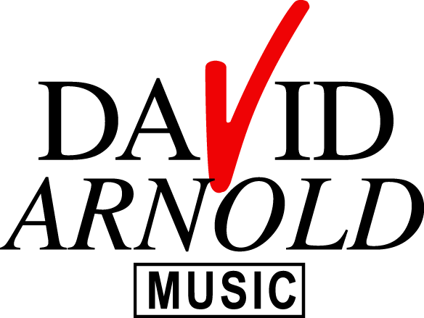

MINSTER FM 2013

LYRIC SHEET FOR RESINGS

1. BREAKFAST

THE JAMES WATT BREAKFAST SHOW, 104.7, MINSTER FM.

2. MORNING

104.7, MINSTER FM

3. KATY

104.7, MINSTER FM

4. 80’s GLEE

104.7, MINSTER FM

5. 90’s BOO

104.7, MINSTER FM

6. BEYONCE

104.7, MINSTER FM

7. GIRLS

104.7, MINSTER FM

8. CEELO

THE JAMES WATT BREAKFAST SHOW, 104.7, MINSTER FM

9. KYLIE

THE SATURDAY NIGHT NON STOP PARTY, 104.7, MINSTER FM

10. FAVOURITE MUSIC

NORTH YORKSHIRE’S FAVOURITE MUSIC, 104.7, MINSTER FM

11. WEATHER

NORTH YORKSHIRE WEATHER, 104.7, MINSTER FM

12. NEWS

13. TRAVEL

14. ELECTION SPECIAL

